**Art/ Design Tech**

Make a vehicle that can move.. It could be rocket, car, aeroplane but it has to move so thin about t’s wheels. Can you write a set of commands/instructions on how you have made your vehicle?

# **Explorers!**

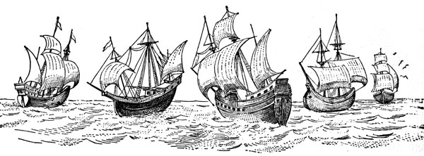

**Home Learning**

We have been hugely impressed with the amount and quality of homework being completed over the last few half terms by pupils. Over the next six weeks, you must complete at least one of the English and Maths activities, and also choose any of the others to complete. As we are giving you a lot of time to complete this homework, we expect good quality work. All activities will also be covered in school at some point over the half term. We will be holding a home learning sharing session in school on **Thursday 24thMay,** so all homework must be handed in by that Wednesday – As always, feel free to be as creative as you like!

**Geography:**

We will be looking at the country ‘Kenya’ in Africa.. Can you find out about the different animals that live there? Maybe draw or make some of them?

**History**

Why do you think Christopher Columbus is important to us? Who was he? What did he do? Write a short report on him.

**Maths**

In our Maths lessons, we are going to be learning about 2D and 3D shapes. Look around your house and your local environments, what different shapes can you see? Draw the shape you can see and write it’s properties.

For example:

I can see: Baked Beans can. It is the shape of a cylinder. A cylinder is a 3D shape, it is curve. It has 3 faces and 2 edges. I can see 2D shape circles.

**Science:**

What do you think plants need to be healthy?

Can you research about your favourite plant/flower? Are they easy to grow? Look after? Why is this your favourite plant/flower?

.

**English**

In English, we are learning about Fairy Tales. Which is you favourite fairy tale and why?

Can you in detail, write your fairy tale, remember if you wanted you could change parts of it.